**CS 628 Full-Stack Development II**

**HOS03C: Responsive Design**

July 16, 2020

12/29/2020 Updated by Min

School of Technology & Computing (STC)

City University of Seattle (CityU)

**Before You Start**

* The directory path shown in screenshots may be different from yours.
* Some steps are not explained in the tutorial**.** If you are not sure what to do:
  1. Consult the resources listed below.
  2. If you cannot solve the problem after a few tries, ask a TA for help.

**Resources**

* Holmes, S. & Harber, C. (2019). [Getting MEAN with Mongo, Express, Angular, and Node, Second Edition](https://login.proxy.cityu.edu/sso/skillport?context=148121). Manning Publications. (ISBN 9781617294754)
  + Chapter 3: Creating and Setting up a MEAN Project
    - 3.4 Importing Bootstrap for Quick, Responsive Layouts
  + Appendix B: Installing and Preparing the Supporting Cast
    - Twitter Bootstrap
    - Font Awesome

**Learning Outcomes**

* Understand responsive design
* Apply responsive design to your application

**Activities**

* Preparing for a MEAN project environment
* **Adding Twitter Bootstrap to your application**
* **Adding Font Awesome to your application**
* **Adding Font Awesome to your application**
* **Adding Bootstrap to the Entire Application by using layout.pug**
* Source Code Management and Deployment

**Preparing for a MEAN project environment**

1. Copy the “module03b” directory to the “module03c” one.
2. Open the “module03c” folder in the VSCode.  
   Close the “Welcome” window.  
   Open the terminal (Ctrl+`).
3. Test whether the application works correctly.  
   >>>npm start  
     
   http://localhost:3000

**Adding Twitter Bootstrap to your application**

1. Bootstrap is not installed but added to your application.    
   Visit <https://getbootstrap.com/>
2. Download ready-to-use compiled code for **Bootstrap** to easily drop into your project, which includes:
   1. Compiled and minified CSS bundles
   2. Compiled and minified JavaScript plugins

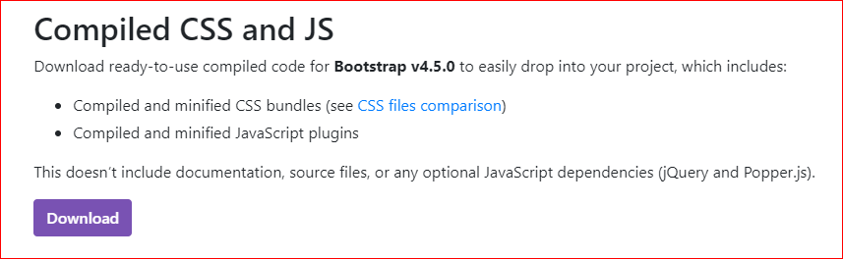

1. When you have the files downloaded and unzipped, move one file from each folder into the public folder in your Express application, as follows:
   1. Copy “css/bootstrap.min.css” into your “public/stylesheets” folder.
   2. Copy “js/bootstrap.min.js” into your “public/javascripts” folder.

|  |  |
| --- | --- |
| Before | After |
|  |  |

**Adding Some Custom Styles to your application**

1. Edit the “style.css” file in your “public/stylesheets” folder with the given content below.

@import url("//fonts.googleapis.com/css?family=Lobster|Cabin:400,700");

h1, h2, h3, h4, h5, h6 {

font-family: 'Lobster', cursive;

}

.navbar-brand {

font-family: 'Lobster', cursive;

}

legend {

font-family: 'Lobster', cursive;

}

body {

font-family: "Cabin", Arial, sans-serif;

color: #ffffff;

background-color: #108a93;

}

**Adding Font Awesome to your application**

Font Awesome, which is an icon library and toolkit, is an awesome way to get scalable icons into your application by using fonts and CSS instead of images.

1. Download the free for web from <https://fontawesome.com/how-to-use/on-the-web/setup/hosting-font-awesome-yourself>
2. When Font Awesome is downloaded and unzipped, follow these two steps:
   1. Copy the entire “webfonts” folder into the “public” folder in your application.
   2. Copy the “all.min.css” file from the “css” folder into “public/stylesheets.”

|  |  |
| --- | --- |
| Before | After |
|  |  |

**Adding Bootstrap to the Entire Application by using layout.pug**

If you want to add some external reference files to the entire application, using the layout file called “layout.pug.”

1. Reference the Bootstrap and Font Awesome CSS files.  
   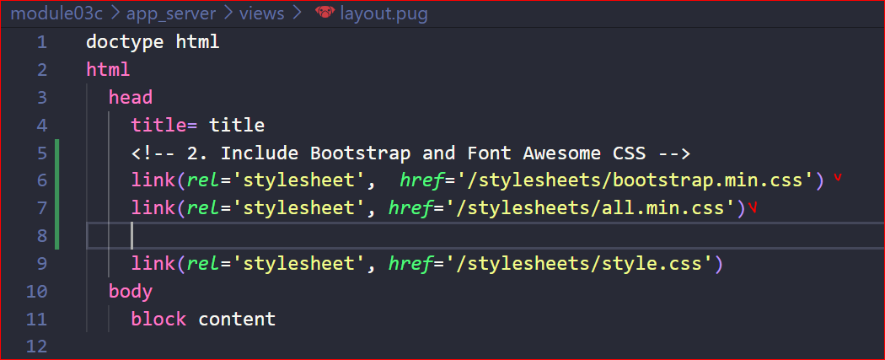
2. Reference the Bootstrap JavaScript file. (Check #2 below.)
3. Bootstrap also requires jQuery and Popper.js for some of the interactive components to work.

Reference jQuery and Popper.js, which Bootstrap requires. (Check #3 below.)

1. Add viewport metadata so that the page scales nicely on mobile devices. (Check #1 below.)

v

doctype html

html

  head

    <!-- 4. Set the viewport metadata for better display on mobile devices. -->

    meta(*name*='viewport', *content*='width=device-width, initial-scale=1.0')

    title= title

    <!-- 1. Include Bootstrap and Font Awesome CSS -->

    link(*rel*='stylesheet',  *href*='/stylesheets/bootstrap.min.css')

    link(*rel*='stylesheet', *href*='/stylesheets/all.min.css')

    link(*rel*='stylesheet', *href*='/stylesheets/style.css')

  body

    block content

    <!-- 3. Bring in jQuery and Popper, needed by Bootstrap. -->

    script(*src*='https://code.jquery.com/jquery-3.3.1.slim.min.js', *integrity*='sha384-q8i/X+965DzO0rT7abK41JStQIAqVgRVzpbzo5smXKp4YfRvH+8abtTE1Pi6jizo', *crossorigin*='anonymous')

    script(*src*='https://cdnjs.cloudflare.com/ajax/libs/popper.js/1.14.3/umd/popper.min.js', *integrity*='sha384-ZMP7rVo3mIykV+2+9J3UJ46jBk0WLaUAdn689aCwoqbBJiSnjAK/l8WvCWPIPm49', *crossorigin*='anonymous')

    <!-- 2. Bring in the Bootstrap JavaScript file -->

    script(*src*='/javascripts/bootstrap.min.js')

1. Run the application for testing.  
   >>>npm start  
   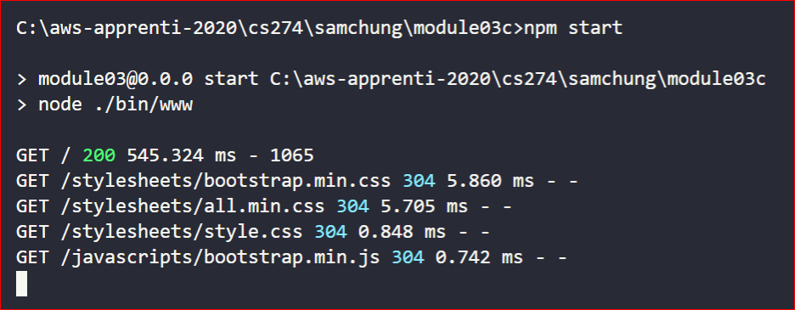  
     
   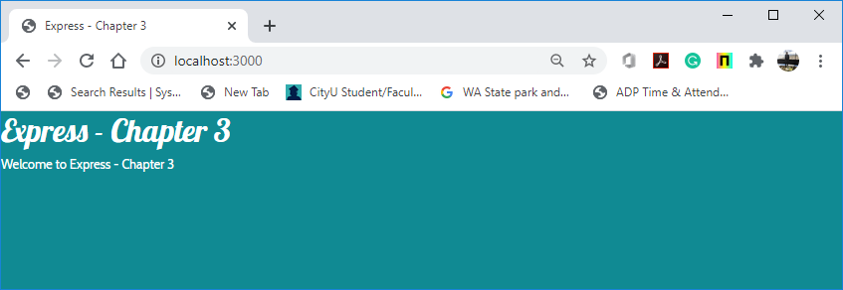

**Source Code Management and Deployment**

**Push your work to GitHub**

Run the following commands to push your work to the GitHub repository:

Open the terminal from the VSCode by hitting the control + ~ key and type the following command:

>>> git add .

>>> git commit -m “Submission for Module 3 --yourname”

>>> git push origin master

**Push your work to Heroku**

>>> git push heroku master

If you cannot remember your branch name, run the command “git status” to check.